Lab Environment
In this lab environment, you will be provided with GUI access to a Kali machine. The target machine running the Mutillidae web application will be accessible at demo.ine.local.
Objective: Perform passive crawling on the web application with Burp Suite.
Solution:

Step 1: Open the lab link to access the Kali machine.
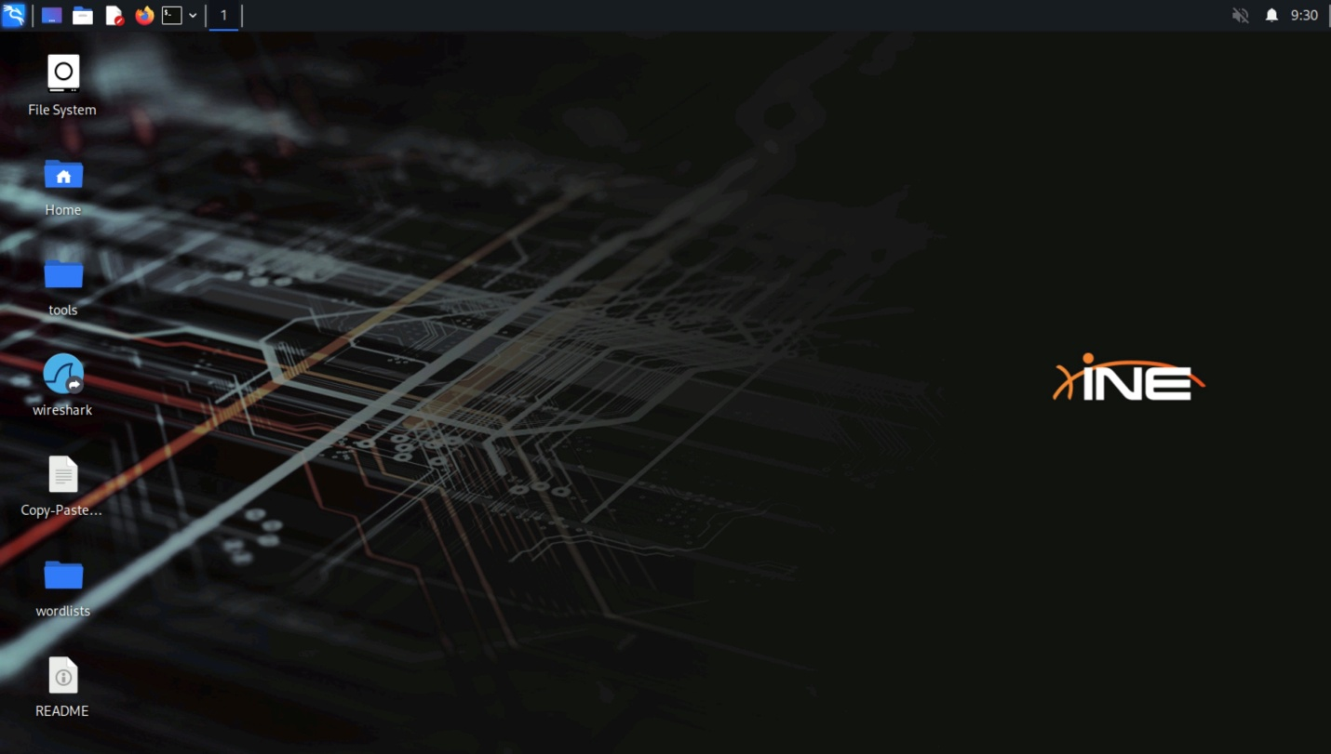
Step 2: Check if the target machine is reachable:
Command:
ping -c 4 demo.ine.local
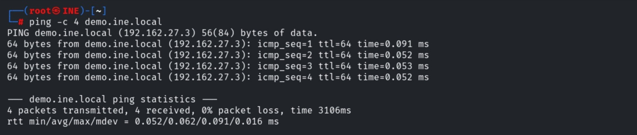
The target is reachable.
Step 3: Run an nmap scan against the target:
Command:
nmap -sS -sV demo.ine.local
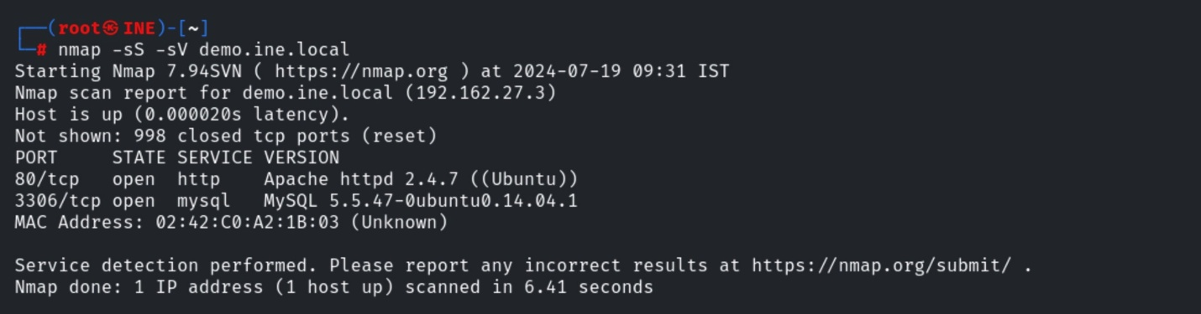
Port 80 and 3306 are open.
Step 4: Access the web application using firefox.
Command:
firefox http://demo.ine.local
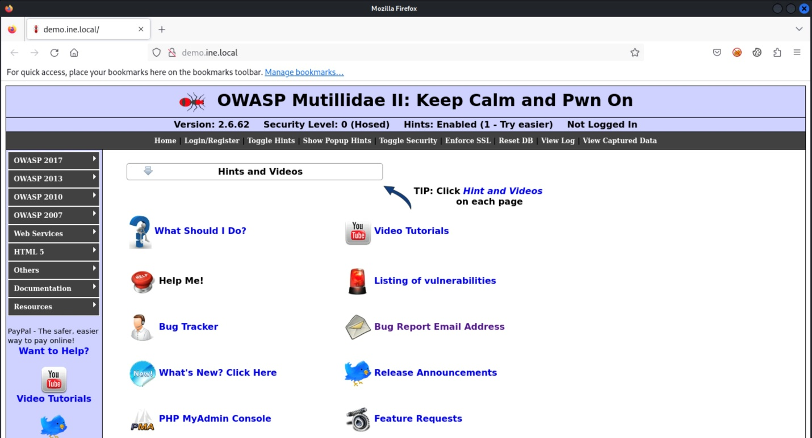
Step 5: The target is running OWASP Mutillidae II. Configure the firefox browser to use burp suite proxy.
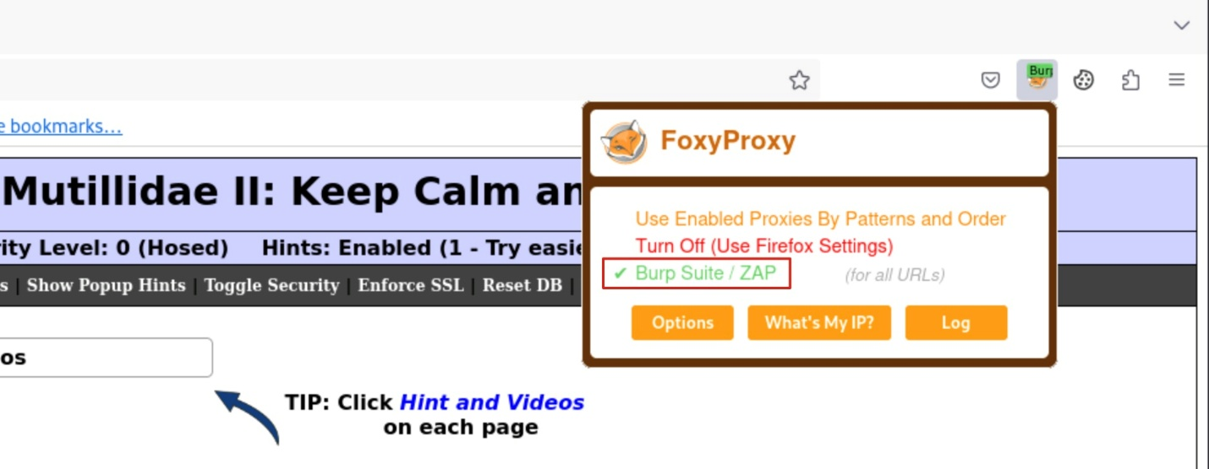
Step 6: Start burp suite.
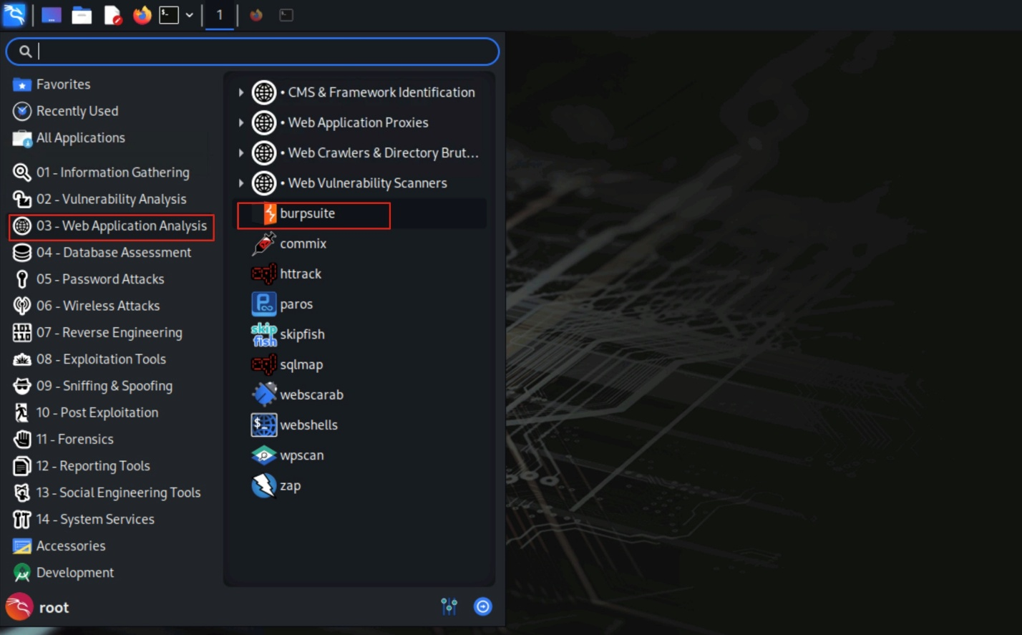
Go to the Proxy tab, and turn off the intercept.
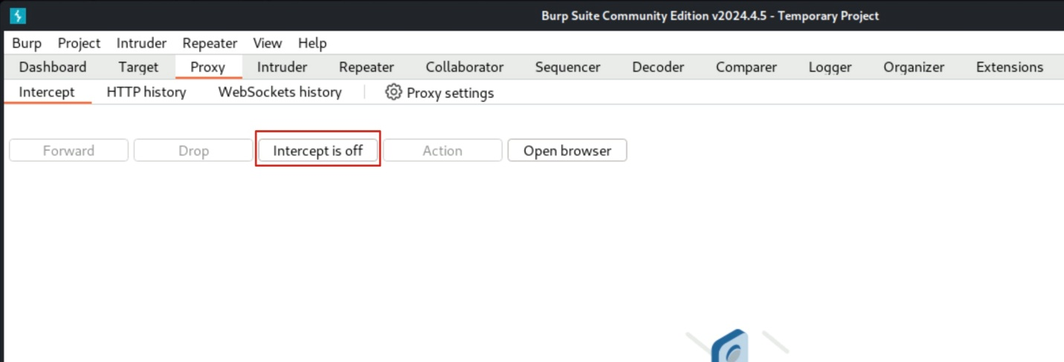
Step 7: Navigate to the Dashboard tab.
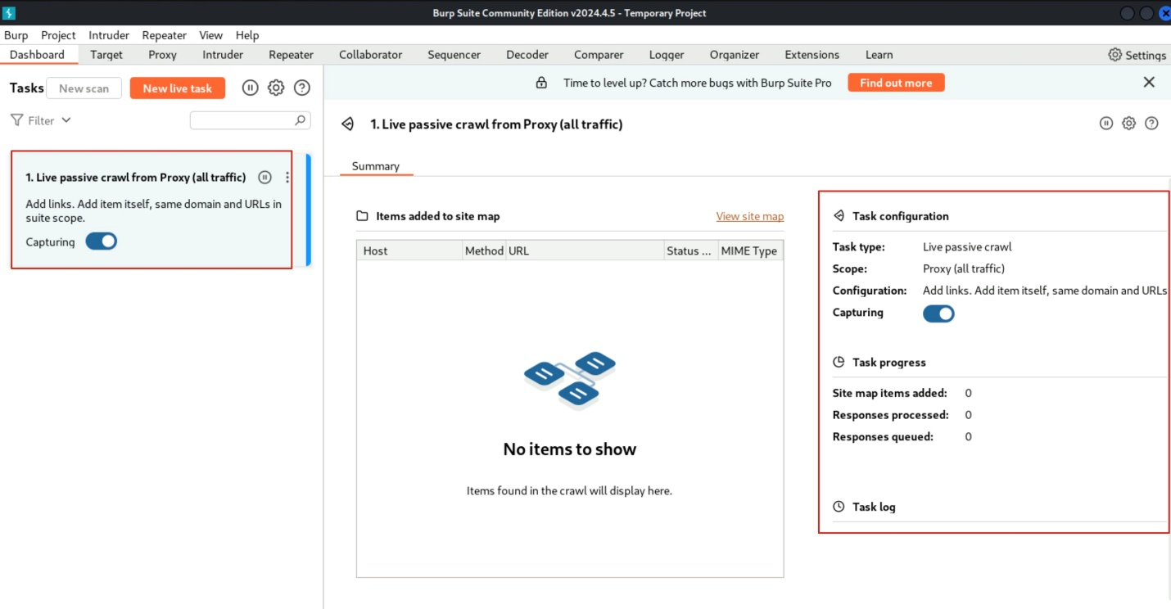
You will see that Passive Crawling is enabled.
Browse the Mutillidae application and burp will automatically crawl the visited pages.
The passive crawler statistics are mentioned.
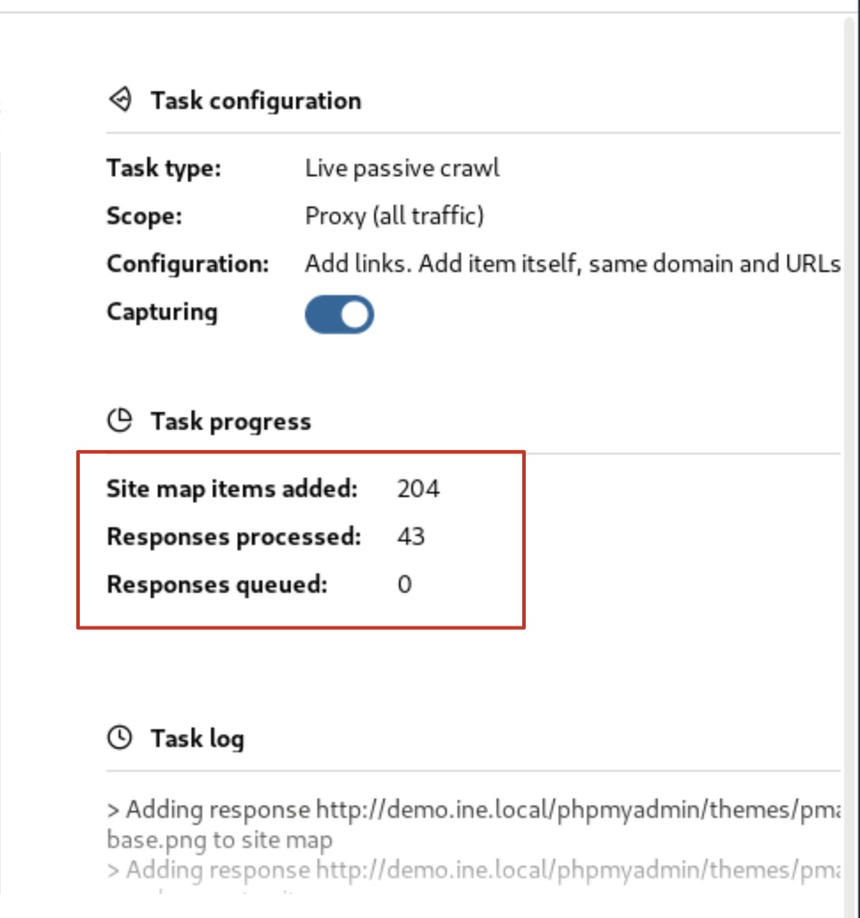
Step 8: Go to the "HTTP history" tab under Proxy.
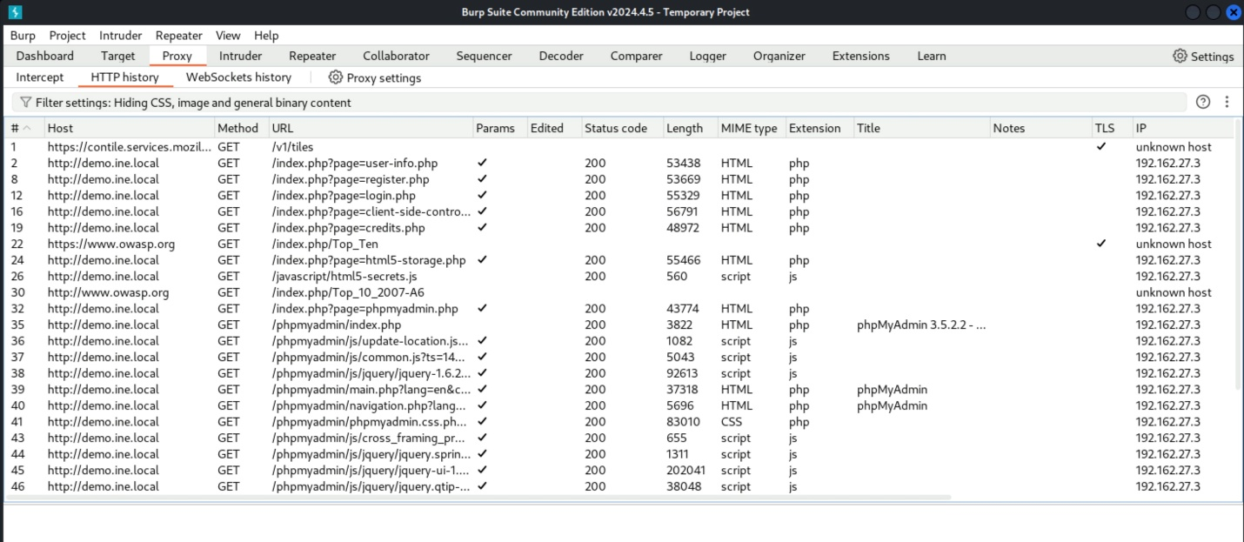
The visited web pages will appear under this tab.
Step 9: Navigate to “Target” tab and the sitemap of the web application will be displayed.
